**Project Design Phase**

**Step 1 : creating a table**

1. Open servicenow personal developer instance.
2. Navigate to All > System Definition > Tables.
3. Click on 'New' button to create a new table.
4. Fill the following details

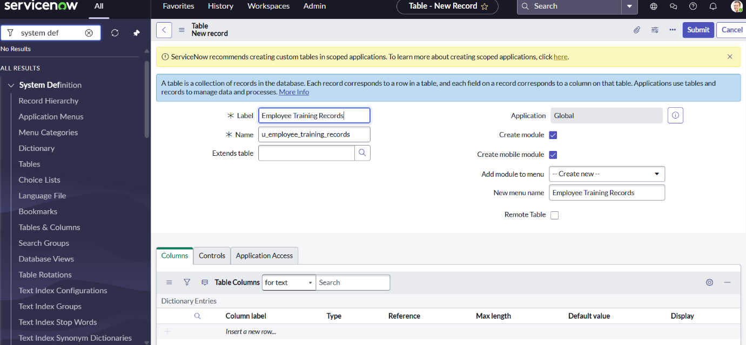

1. Add the following fields:
2. Training Name (Type: String)
3. Completion Date (Type: Date)
4. Status (Type: Choice)
5. Employee(Type: Reference), (Reference field to sys_user table)

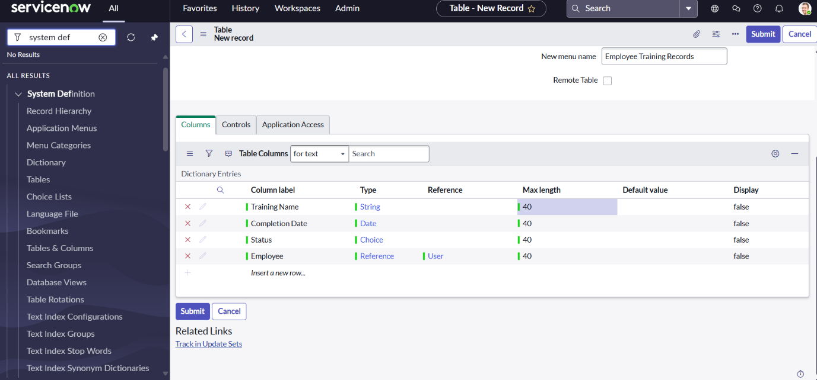

1. Click on submit
2. In application navigator search for the table you have created just now i.e ‘Employee Training Records’.
3. Click on module ‘Employee Training Records’.
4. Click on new button, there you will find the new ‘status’ field. Right click on it and click ‘Configure Dictionary’.
5. You will be entered into the ‘Dictionary Entry Status’. Scroll down and look for choices tab.
6. Under Choices tab click ‘new’ and fill the following details.

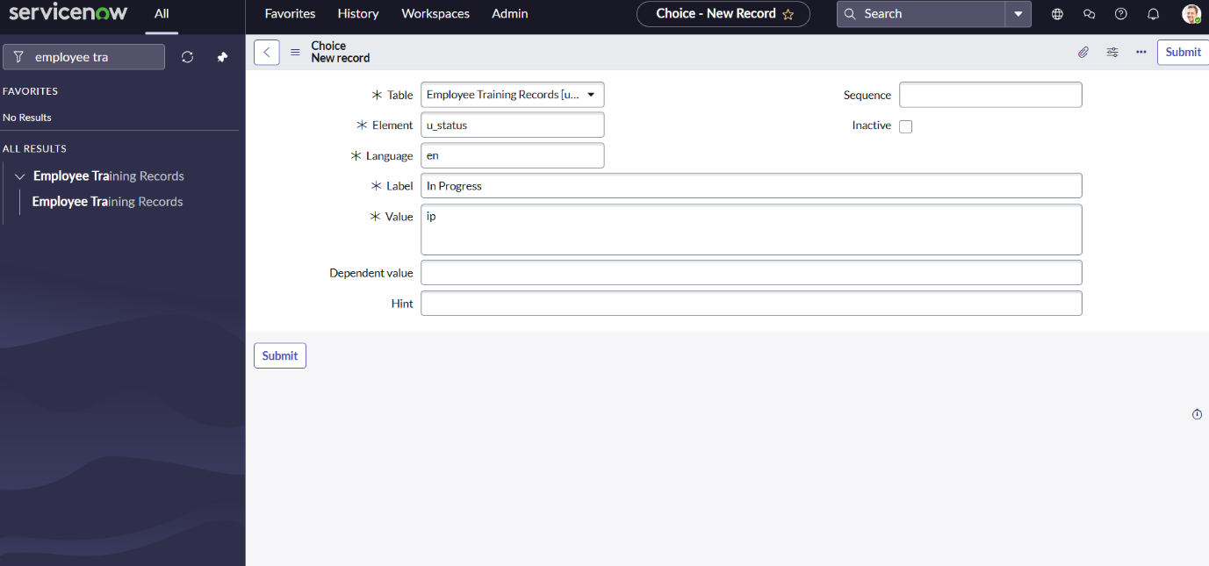

1. Click on submit.
2. Similarly add ‘Completed’ choice with value ‘c’ and click submit. Then it will look as follows :

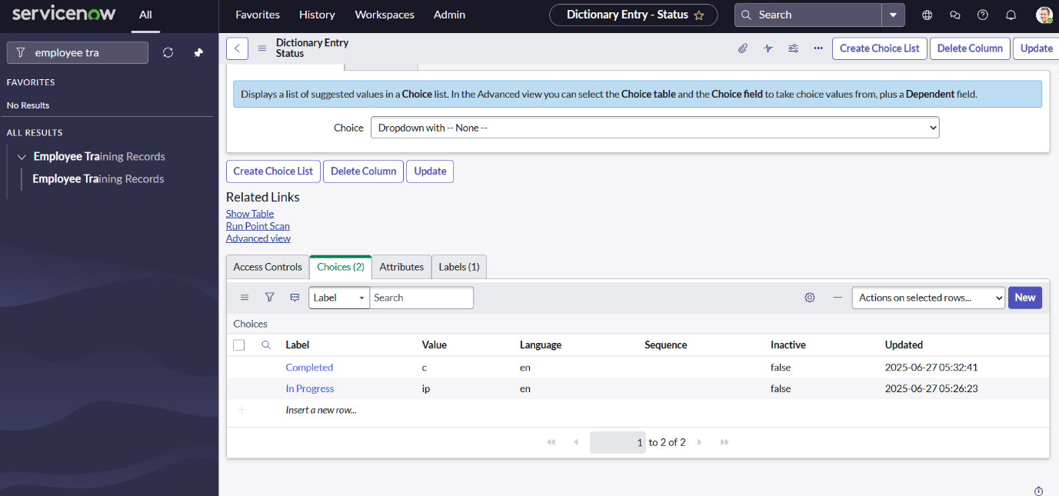

**Step 2 : Importing Data and Mapping the fields**

**Importing Data :**

1. Navigate to All > System Import Sets > Load Data.
2. Choose the excel file and fill the form as below :

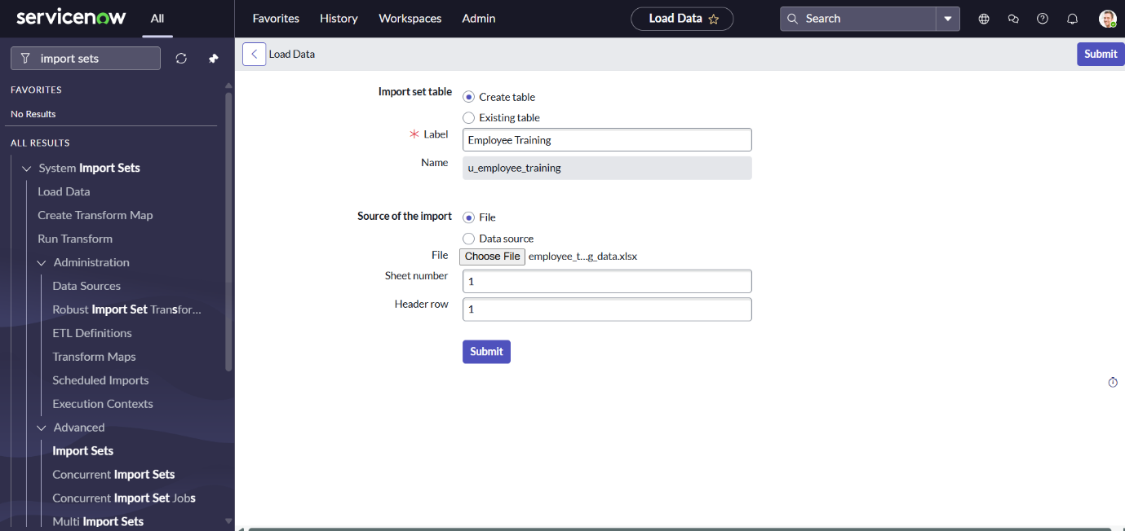

1. Click on submit and you will see the status as below :

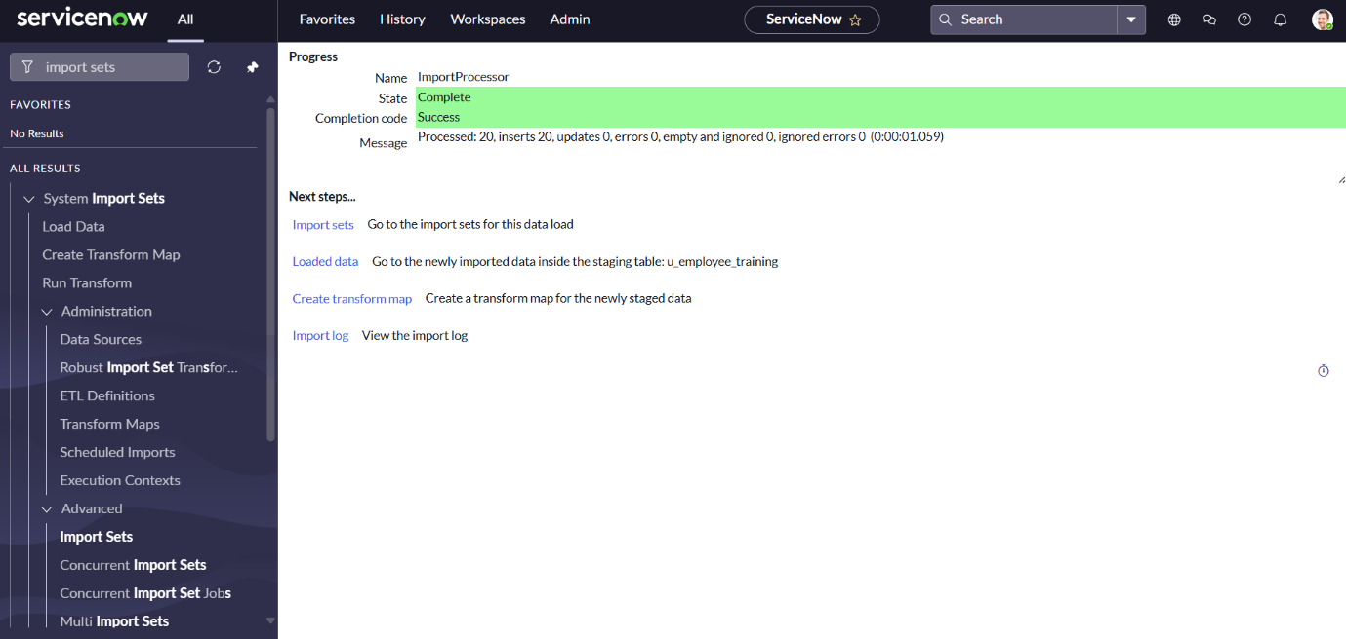

**Mapping Data :**

1. Navigate to All > System Import Sets > Create Transform Map.
2. Fill the following details to create a new table.

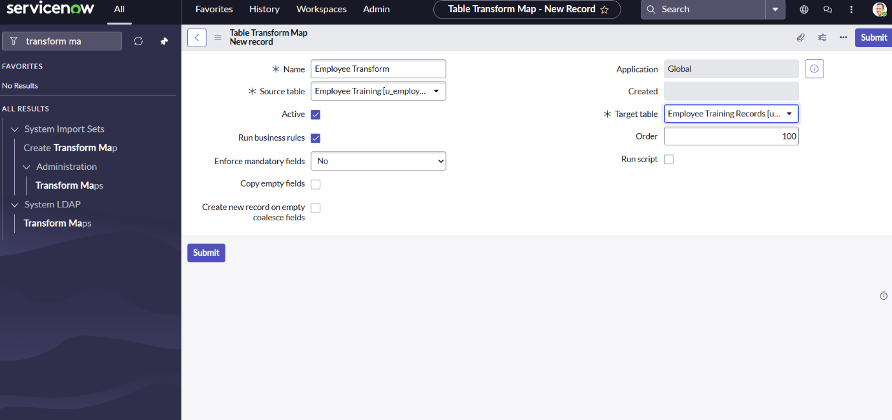

1. Click on submit.
2. Scroll down and you will see fields tab in that click new button and fill the form as below :

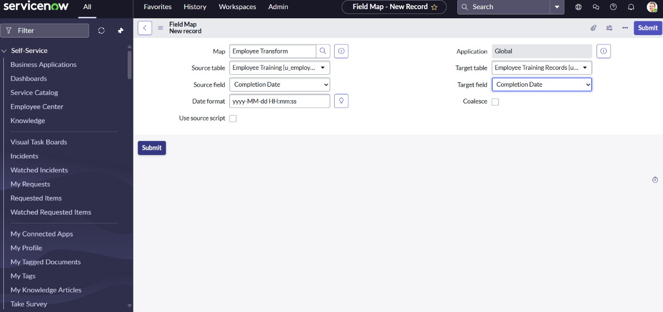

1. Similarly add the remaining fields as in shown below :

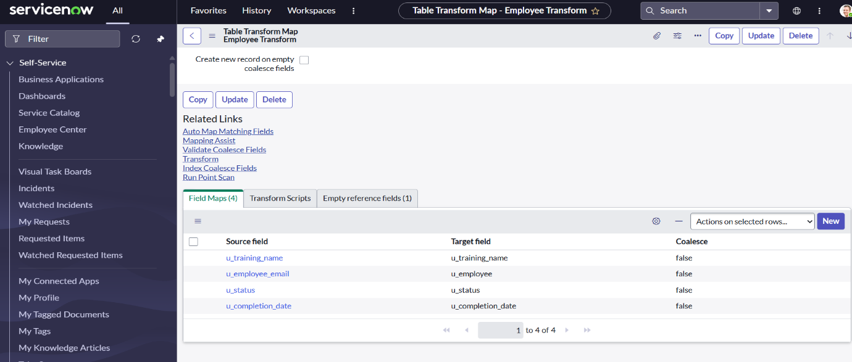

1. In the related links click on transform map and click transform.

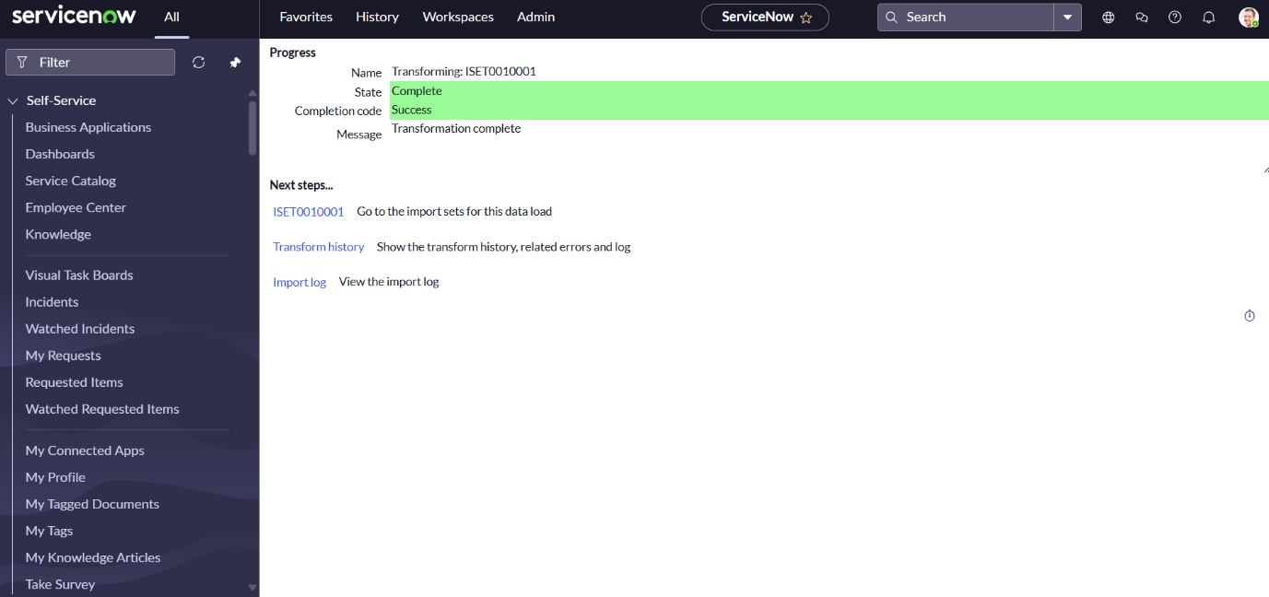

**Step 3 : Using Dot Walking to Access Employee Department Information**

1. In the application navigator search for Employee Training Records and click on that module.
2. Click new button and you will navigate to the form.
3. Click on context menu > configure > form layout.
4. Click on employee which has + icon beside. When you click on it you will see new option above the ‘>’ button.
5. Search for department field in that and double click on it or use ‘>’ to add to the form.
6. And keep the fields in the selected list as shown below.

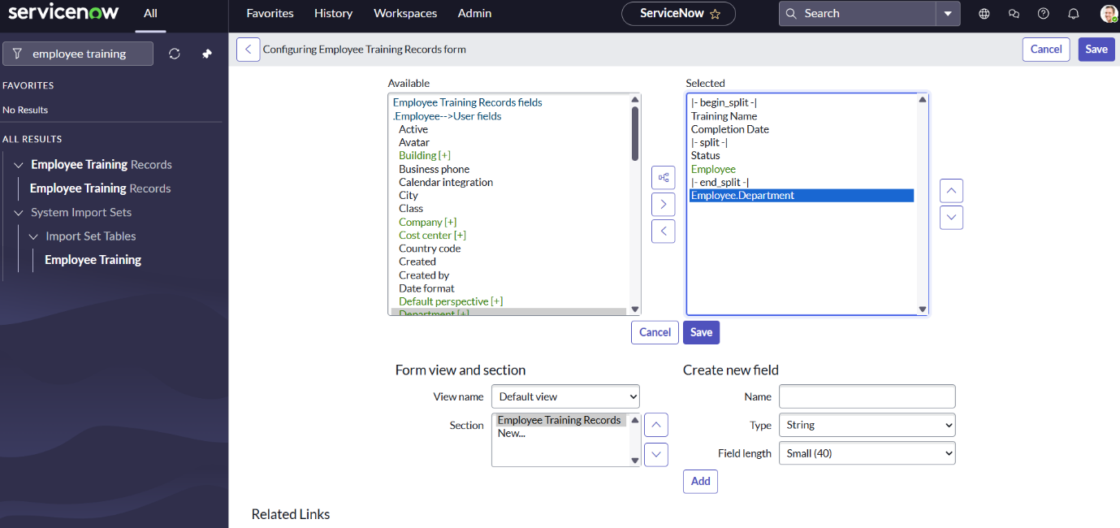

1. Now you can see the fields in the form.

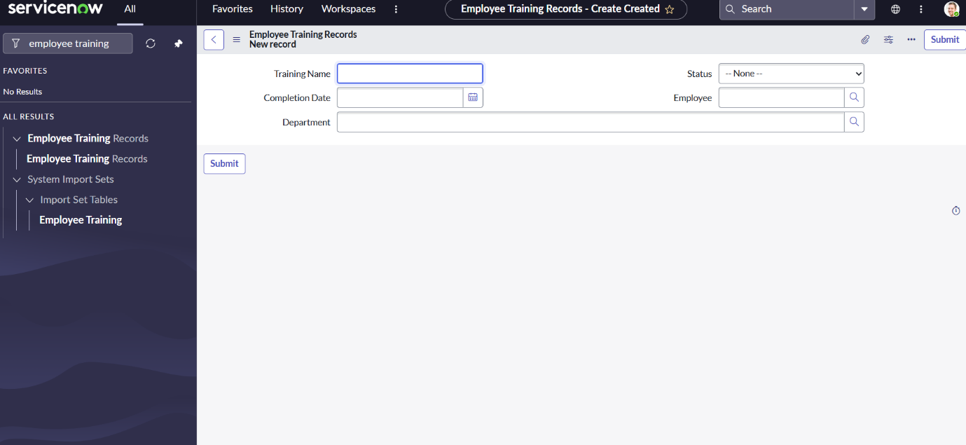

**Step 4 : Creating an ACL (Access Control List)**

1. First you need to Elevate the role to security_admin.
2. Go to user menu and click elevate role and check security_admin and update.

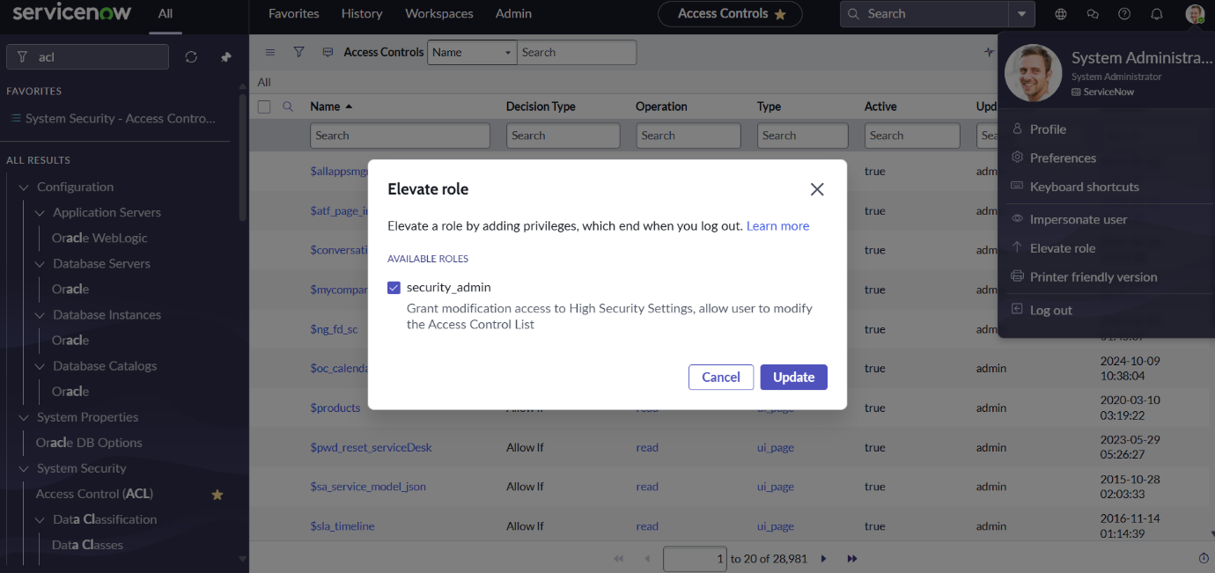

1. Navigate to All > System Security > Access Control (ACL)
2. Click on new button. This is only visible if you have elevated the role as shown.
3. Define ACL (Employees)
4. Operation: Read

**Step 5 : Creating Roles**

1. Create Hr manager role. Navigate to All > system security > users and groups > roles
2. Click on new and name as Hr Manager and click submit.

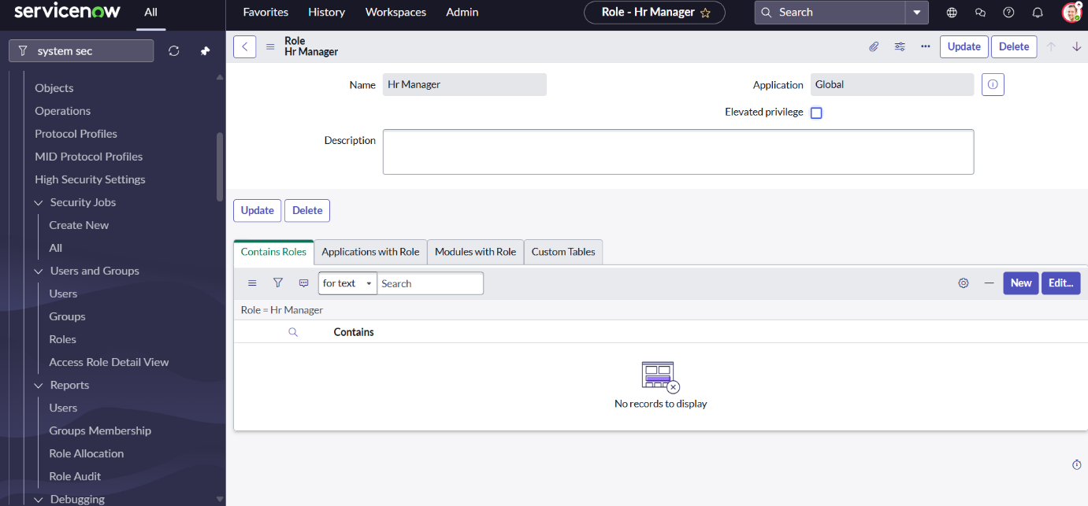

1. Create backup user i.e manager. Navigate to All > system security > users and groups > users
2. Add the following roles to the backup user.

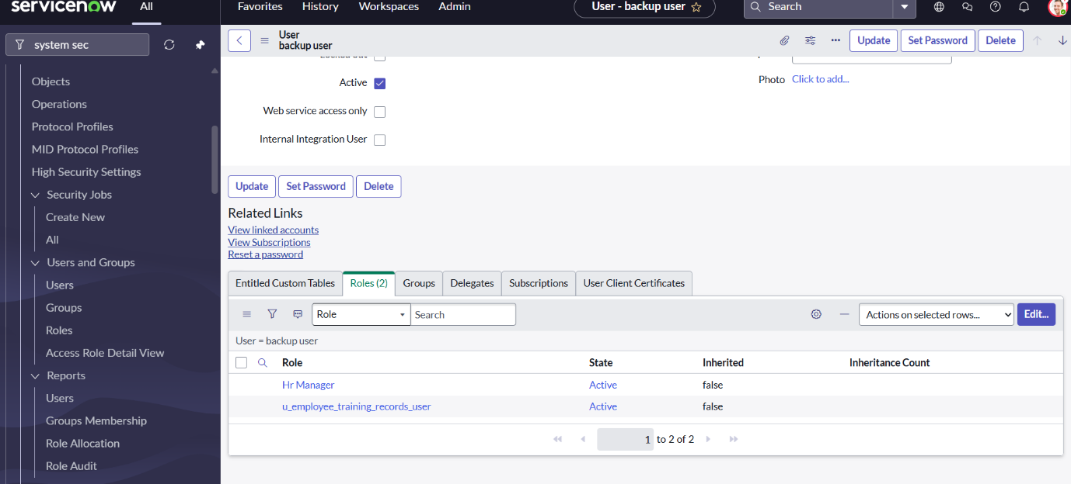

1. Add the Hr manager role to application.

Navigate to All > System Definition > Application menus

1. Search for the table Employee training records. Open it.
2. Click on roles pencil icon and Add the Hr manager role.
3. Click done and update the record.

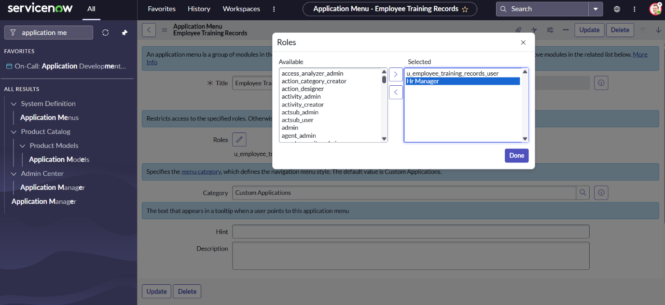

1. Similarly add the Hr manager role to module. Go to All > System Definition > Modules.

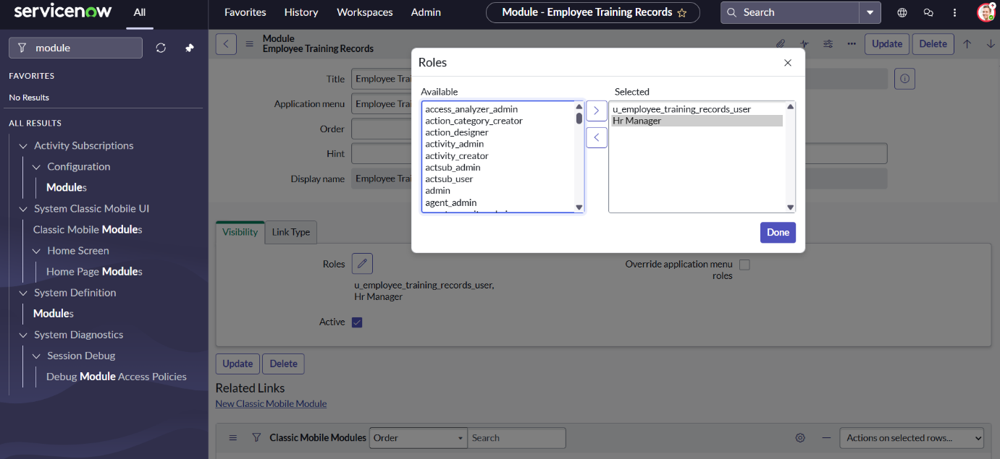

**Update to Elevate Role :**

1. Navigate to All > System Security > Access Controls (ACL) .
2. Click on new and give write access to Employee Training Records as shown below.

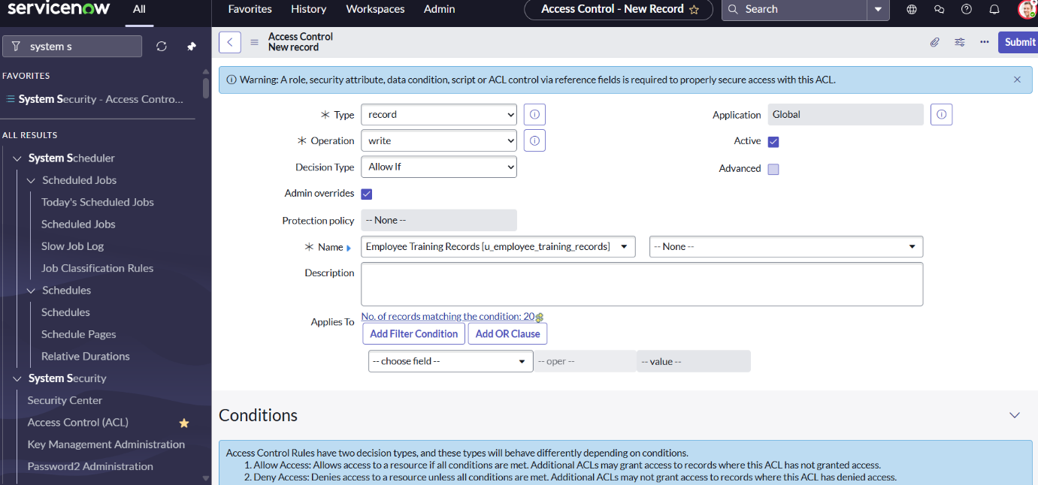

1. Add Hr manager role as shown below :

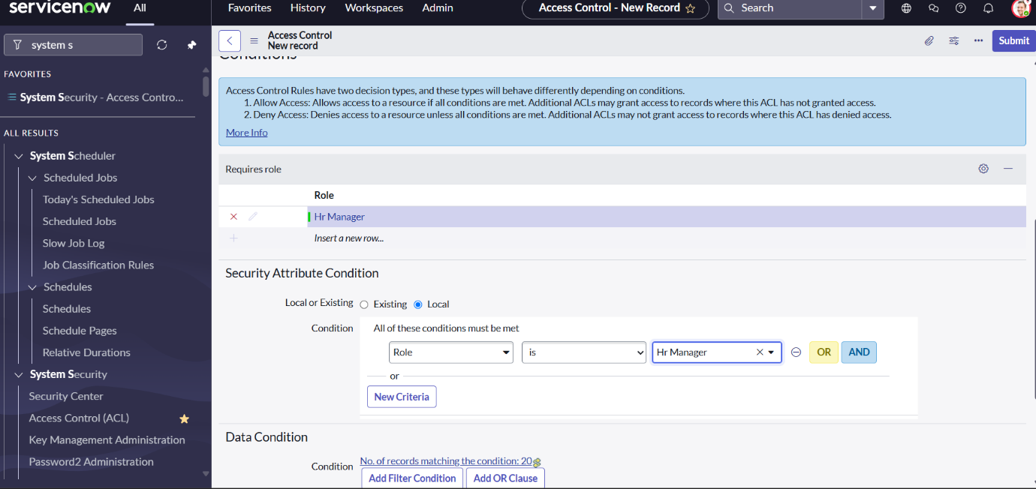

1. Click on submit and continue
2. Similarly create write access and add Hr manager role

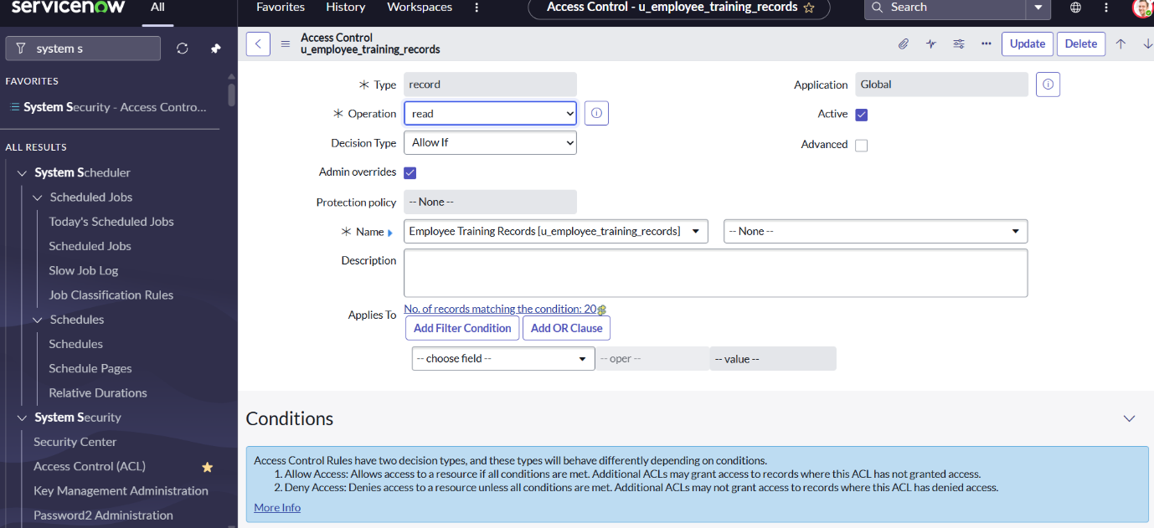

**Step 6 : Testng Results**

1. Impersonate the backup user and we can see that the user is able to access the application, modules as well as data in that.
2. To impersonate go to user menu and click impersonate and search for backup user and click impersonate.
3. Search for employee training records.

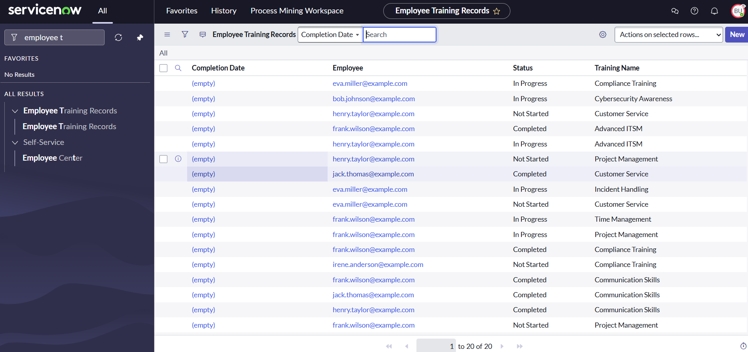

1. Impersonate another user let say abel tutor

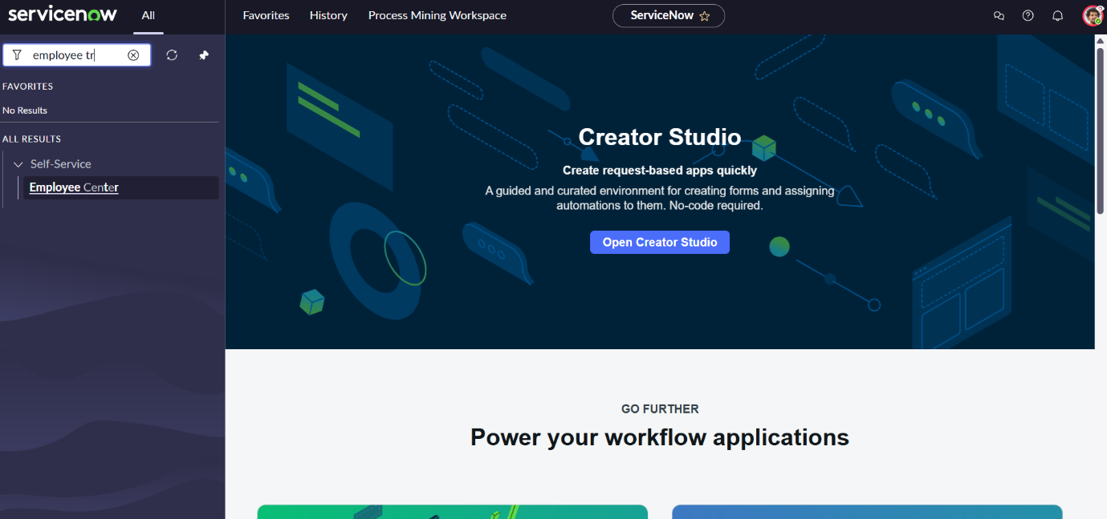

1. In the above picture we can see that the user is not able to see the applications and modules. Hence it is secured.

**Conclusion :**

This project demonstrated the essential process of importing data into ServiceNow using Import Sets, leveraging dot-walking to access and utilize related table data efficiently, and applying Access Control Rules (ACLs) to enforce robust data security. By combining these core functionalities, we ensured accurate data integration, streamlined data relationships, and protected sensitive information through role-based access control.